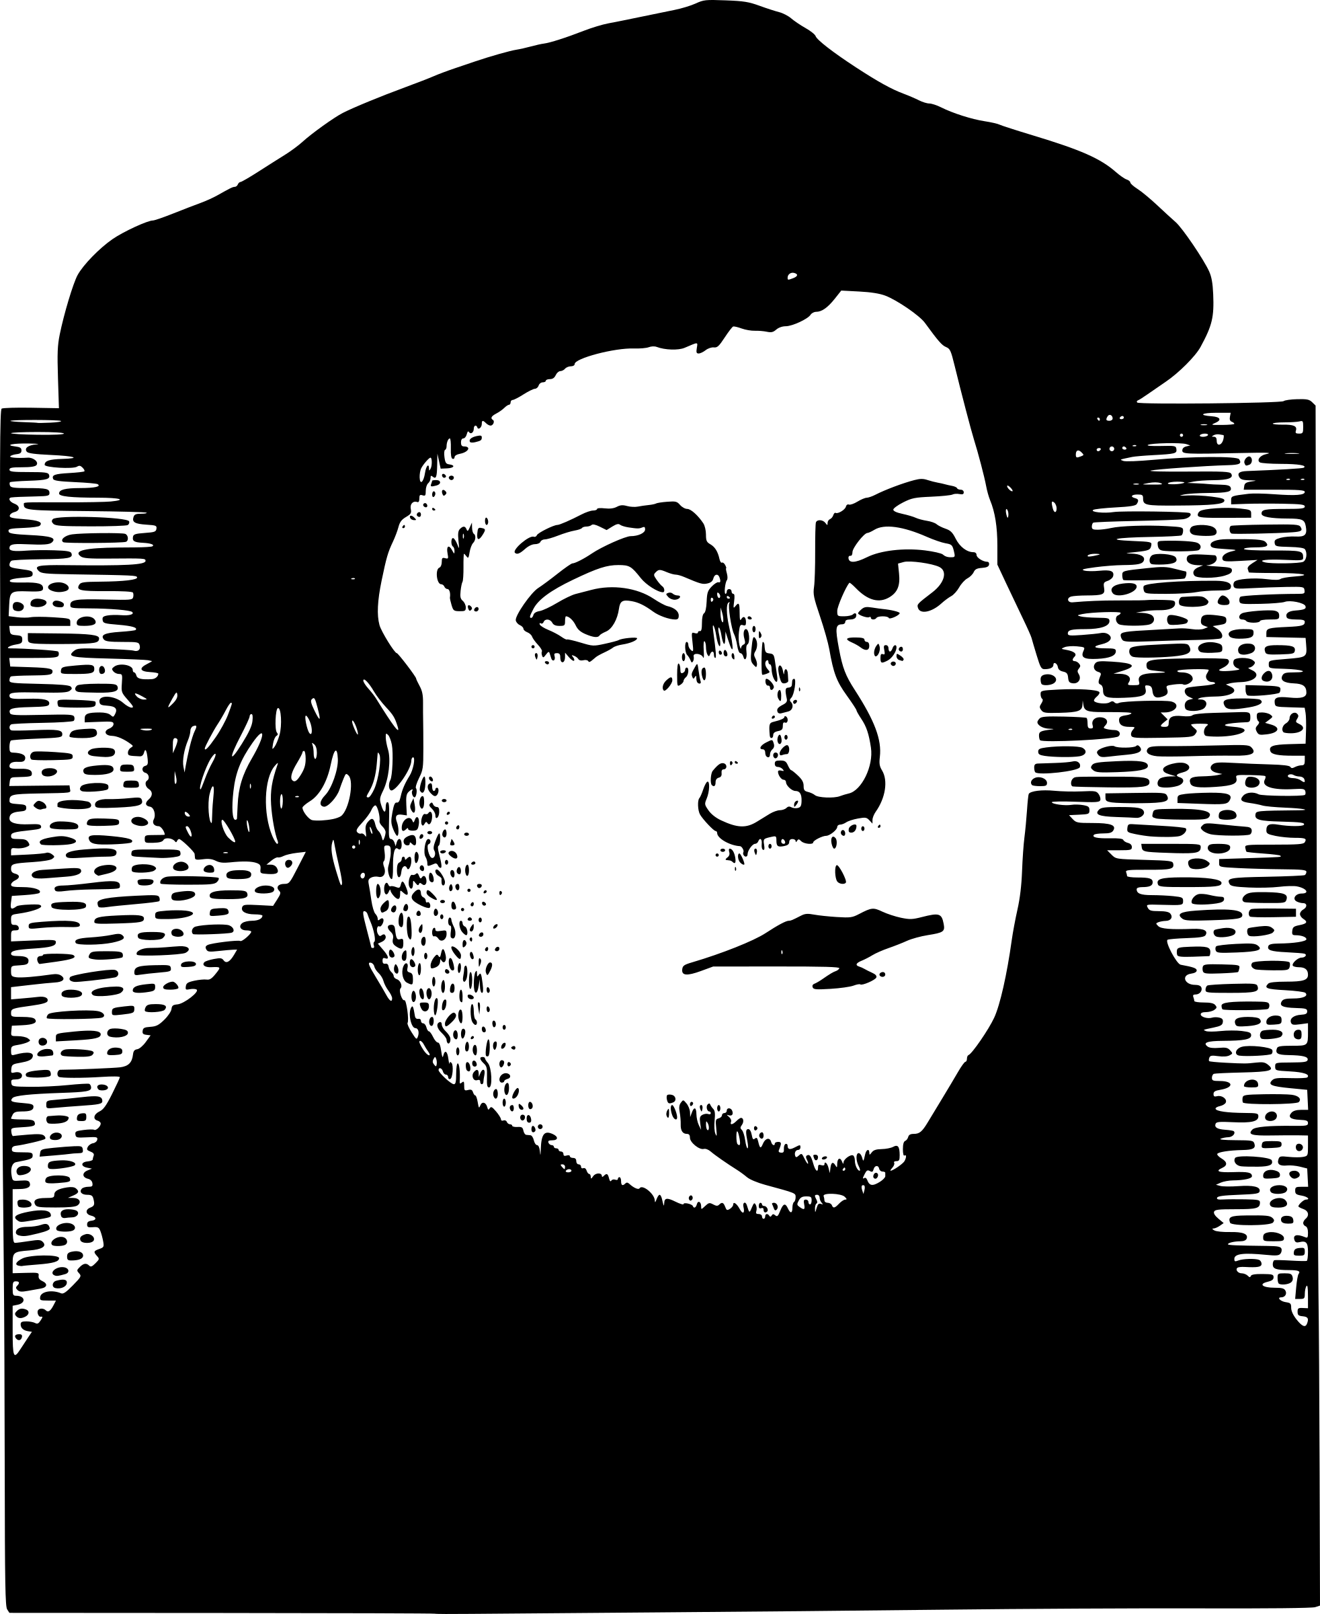
1. When and where was Martin Luther born?

2. What did Luther's parents want him to become?

3. What did Luther want to do?

4. What did Luther experience that caused him to decide to become a monk?

5. What did Martin Luther join? Why?

6. How many points did Martin Luther disagree with the Catholic Church about?

7. What was an indulgence?

8. Why was the pope upset with Luther?

9. Luther was called a heretic. What was the punishment for this crime?

10. What language did Luther translate the Bible into?

11. What new religion did Martin Luther begin?

