Halloween Colors

Directions: Type the Halloween color in the box and use the Text Color to match each color.

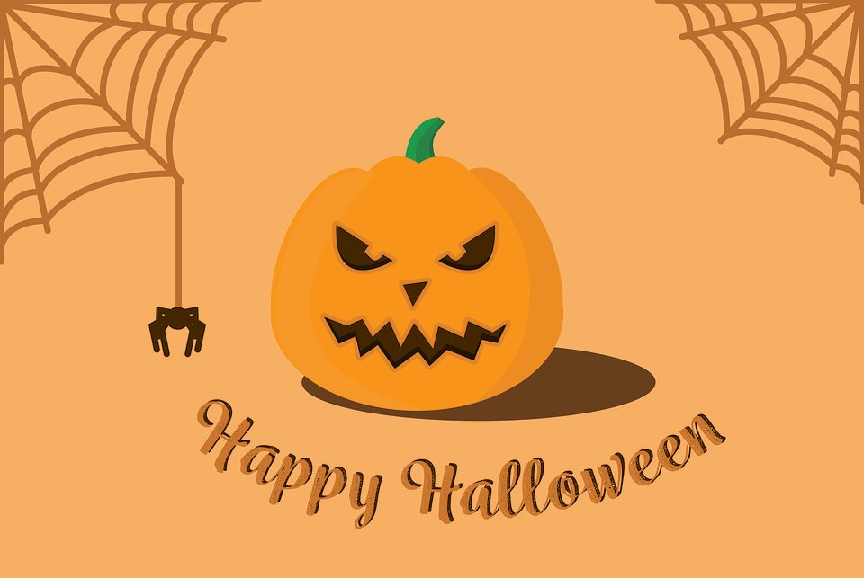

Halloween Costumes

Directions: Type a numbered list of at least 5 costumes you have dressed in for Halloween.
Press the ENTER key after typing each costume. Bold your favorite costume.

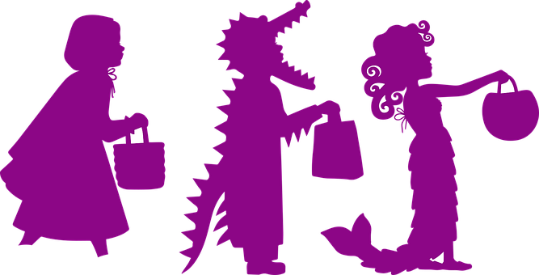

Halloween Candy

Directions: Change the Font Size and Text Color of your 5 favorite candies to get when you go trick or treating.

Snickers | Milky Way | Candy Corn | Skittles | Swedish Fish
3 Musketeers | Blow Pops | Starbursts | Lemonheads | Salt Water Taffy
Bubble Gum | Life Savers | Reece’s Pieces | Twix | Sour Patch Kids
Butterfinger | Kit Kat | Hershey’s | Almond Joy | Hot Tamales
Heath bar | Twizzlers | Popcorn Ball | Sweetarts | Krackel
Payday | Milk Duds | Junior Mints | Whoppers | Tootsie Rolls
Nestle’s  Crunch | M&Ms  Plain | M&M’s  Peanut | Hershey’s  Kisses | Reece’s Peanut Butter Cups

Type It!

Directions: Type your 5 favorite candies in order from your most favorite to your least favorite.

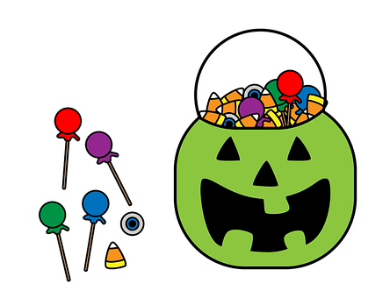

Halloween Rhyming Words

Directions: Type a rhyming word in the box below the word. Type the words in orange or purple.
Use this word list:

cones mouse pitch cat sandy most

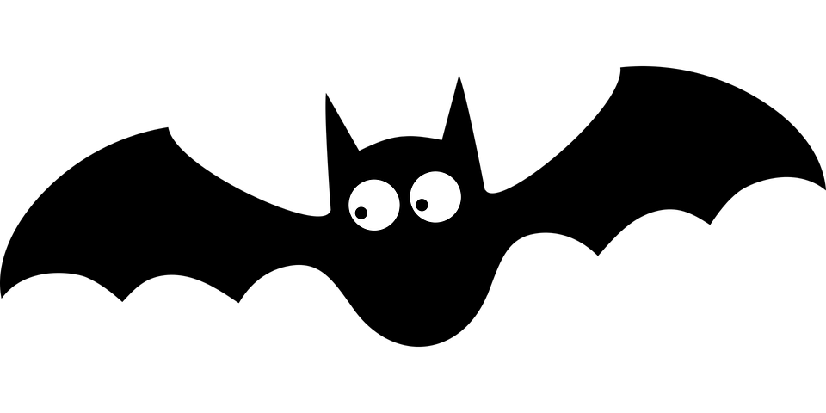 | 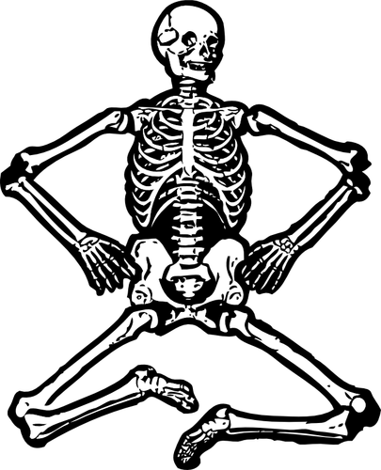 | 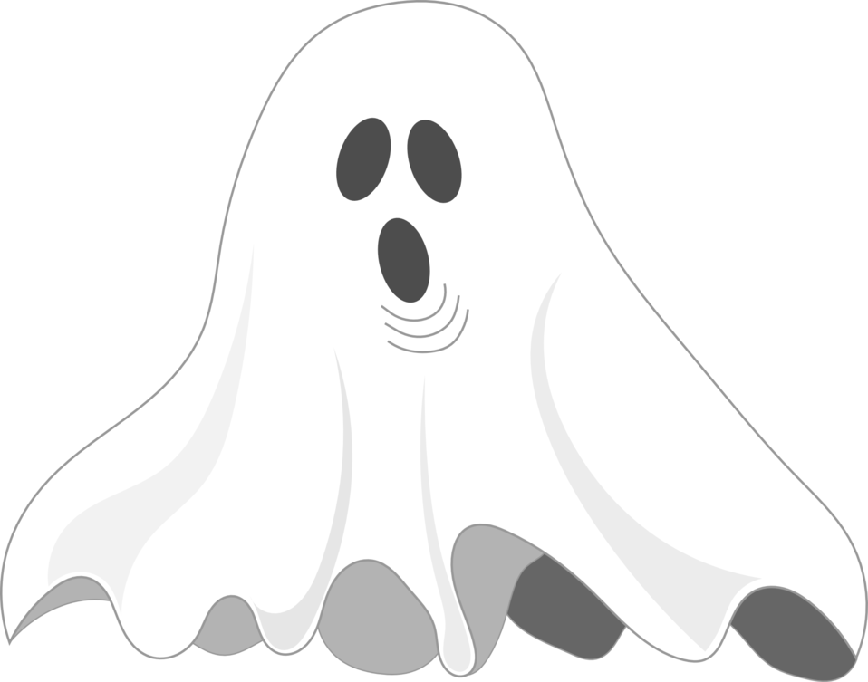
bat | bones | ghost
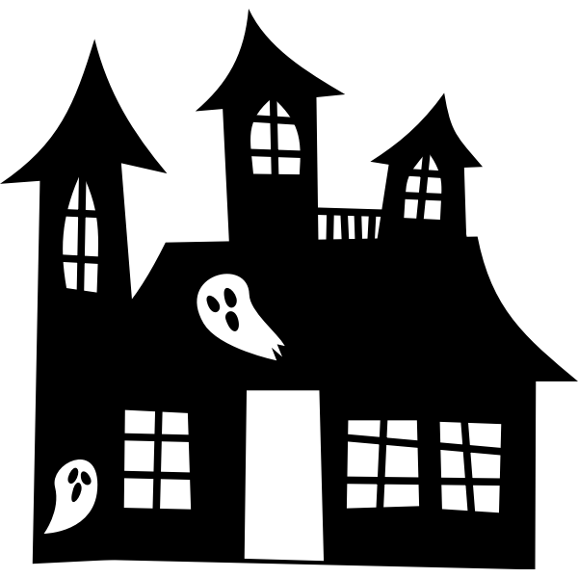 | 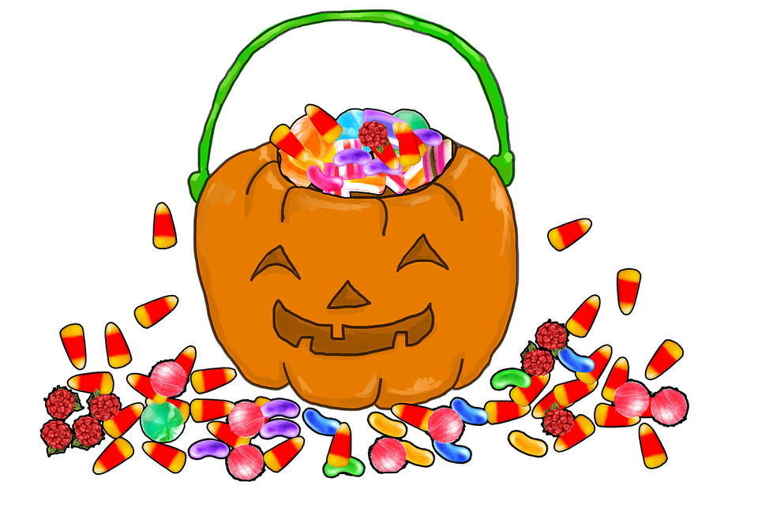 | 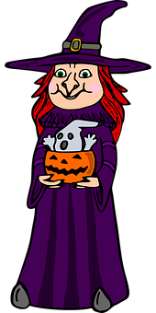
house | candy | witch

Halloween Scary Things

Directions: Change the Font Style and Font Size to all these scary Halloween things.

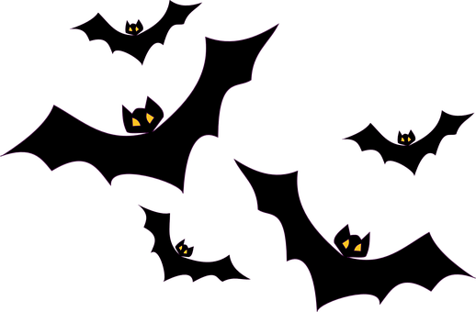 | bats
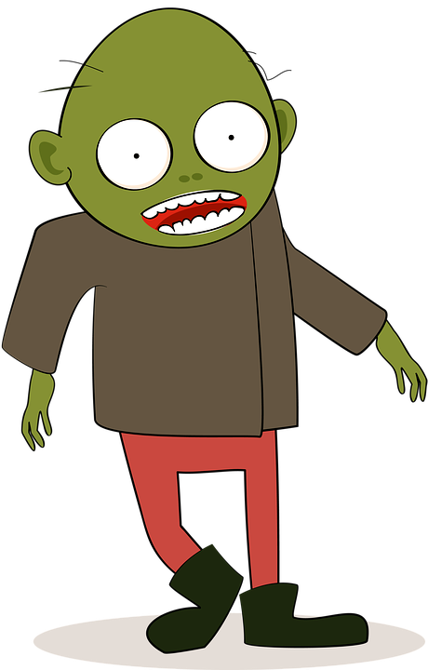 | zombie
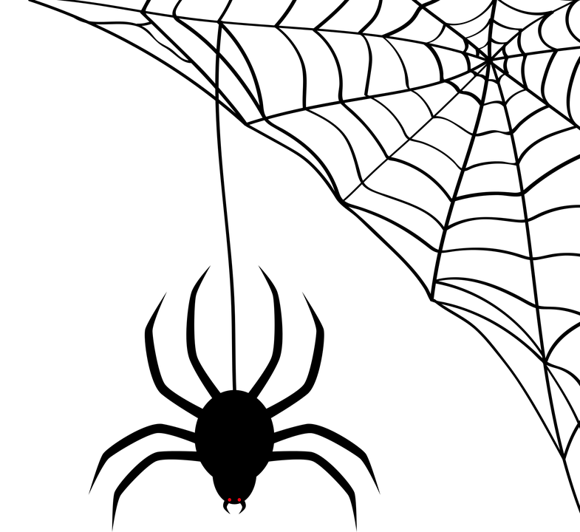 | spiders
 | vampire
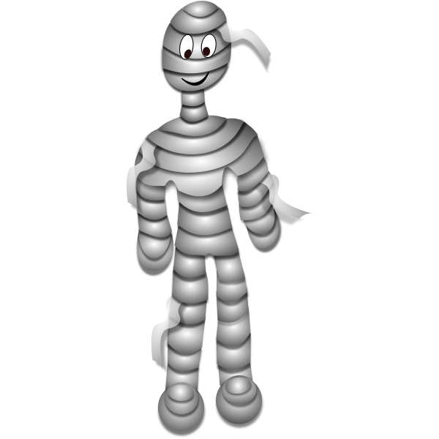 | mummy
Halloween Adjectives

Directions: Read the Halloween story and use the orange highlighter color to highlight describing words (adjectives).

It was a spooky Halloween night. The moon was bright yellow on this cool evening. As my friend and I began trick or treating, we saw a black cat cross the street right in front of us! As we began our walk, we could see all of our friends in scary costumes. Ava was wearing a big witch hat with a purple cape. Jackson had on a black and white skeleton costume. As we got to the end of the street, we could see several beautiful jack-o-lanterns along many of the driveways.

As we turned down the street, when we were walking under the big, oak tree, a creepy spider nearly landed on my head as it was working its way down the web. My friend screamed and scared me more than the spider did. We continued to trick or treat and felt a chill in the air. We were collecting a huge bag of candy, including our favorites such as chocolate bars, tart Lemonheads, and yummy Twizzlers!

It was nearly 8:30 when we realized we needed to get home. My friend and I had a fun Halloween night together. When I got home, I ate some delicious candy and went to bed.

