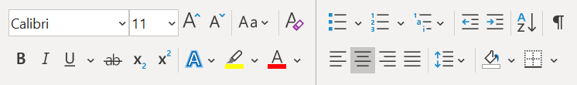
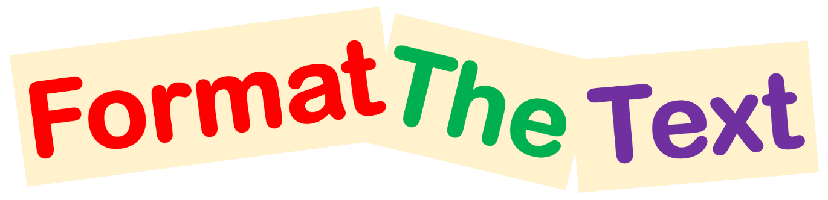

Read the instructions below and use one of the following Formatting Tools on them

Make me font style Comic Sans MS
Make me bold
Center align me
Left align me
Make me size 20
Make me green
Make me italic
Underline me
Right align me
Make me orange
Make me size 12
Make me font style Times New Roman
Add Paragraph Shading (hint: use the paint bucket)
Add a bullet to me
Bonus
Make my letters all Uppercase (without retyping)

