Name:

Copy and paste the words and pictures into the matching boxes.

Orange
Green
Yellow
Purple
Brown
Black
Pink
Grey
Blue

 |  | 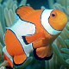 |  | 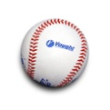

Baseball
Basketball
Kitty
Fish
Penguin

